OIL PAINTING SUPPLY LIST

OIL PAINT
- DO NOT BUY COLORS THAT HAVE THE WORD BARIUM.
- 1.25 - 2FL OZ PAINT TUBES (except for White 5FL OZ)
- OIL COLOR: (Artist-quality oil paint: Winsor & Newton or Grumbacher) DO NOT BUY ART ADVANTAGE OIL PAINTS

Titanium White 5fl oz
Cadmium Yellow Med or Pale

Yellow Ochre

Cadmium Orange

Cadmium Red Medium

Alizarin Crimson

Burnt Sienna

Burnt Umber

Paynes Gray

Cobalt Blue

Cerulean Blue hue

Ultramarine Blue

Chromium (Oxide Green) or Oxide of Chromium (looks like grass green)

Sap Green

NATURAL OR SYNTHETIC BRUSHES

Wash – 1 inch – synthetic
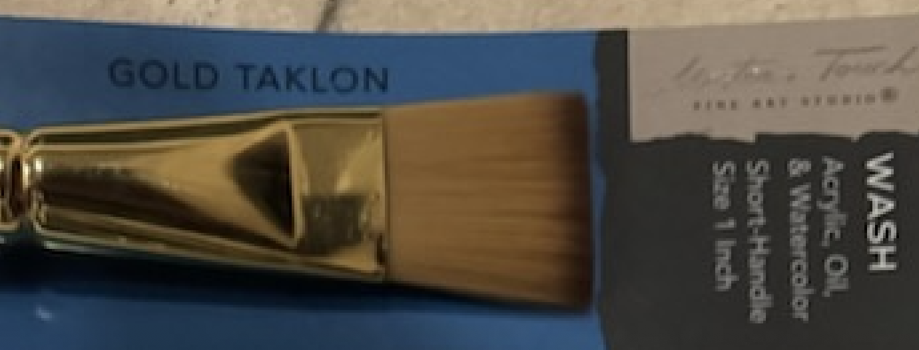
Flat ¾ inch- synthetic
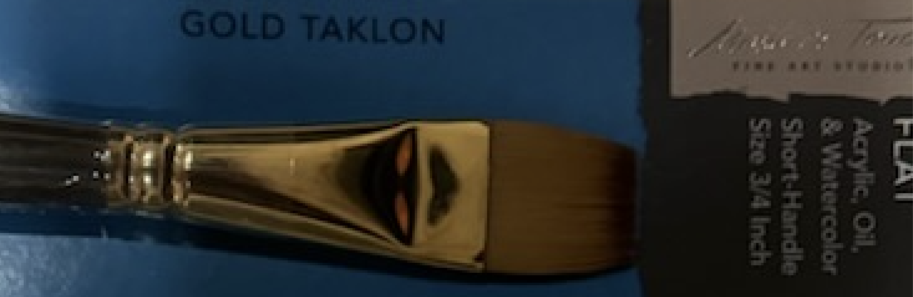
Flat 3/8 inch - synthetic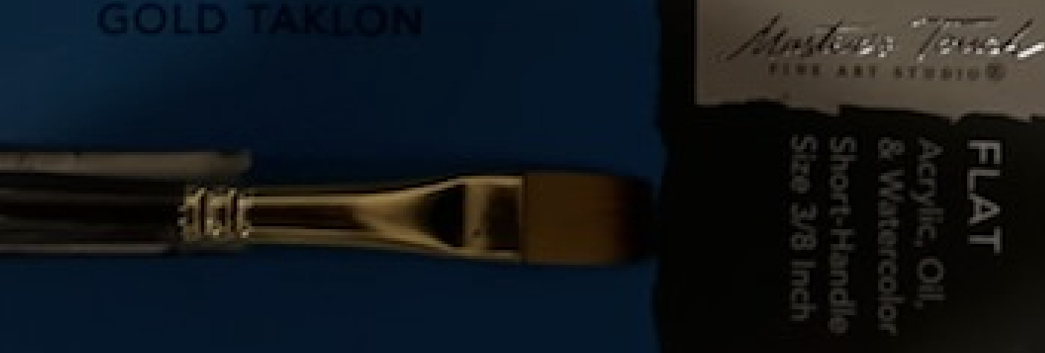
Size 2 – Round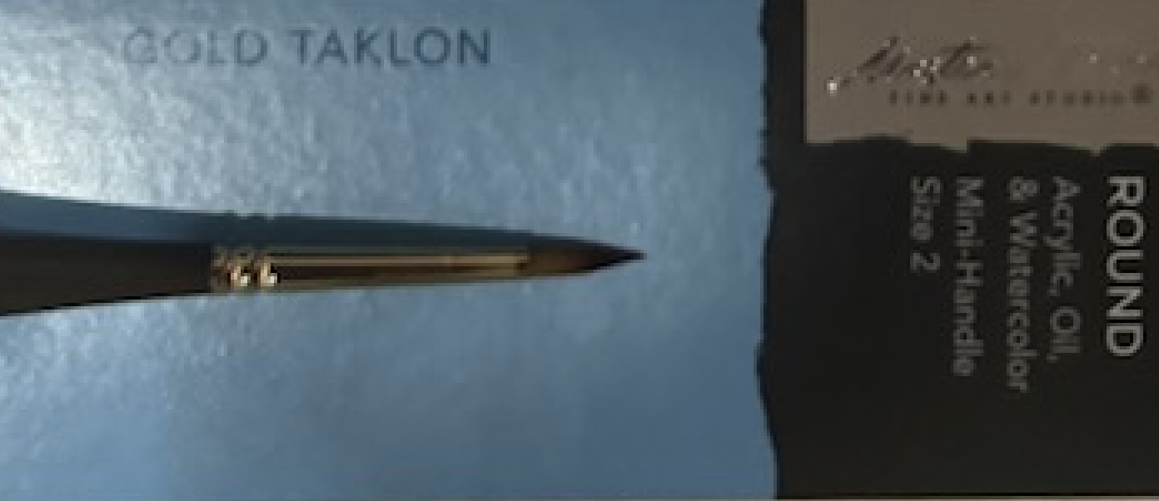
PALETTE KNIFE:
Palette knife, metal blade, wooden handle, curved blade
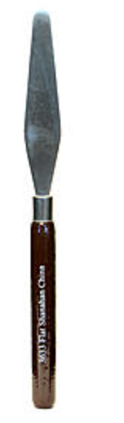
DISPOSABLE OIL PALETTE PAPER - 12” X 16”
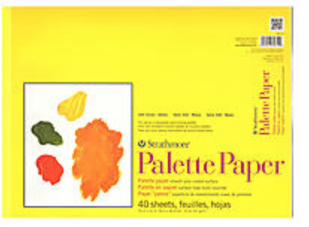

MASTERSON ARTIST PALETTE - 12’” x 16” ( blue lid) - Amazon

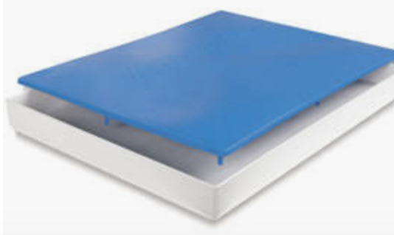

REFINED LINSEED OIL
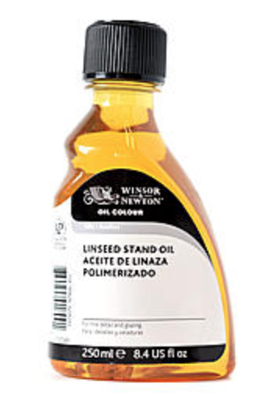

1 Quart ODORLESS TURPENOID

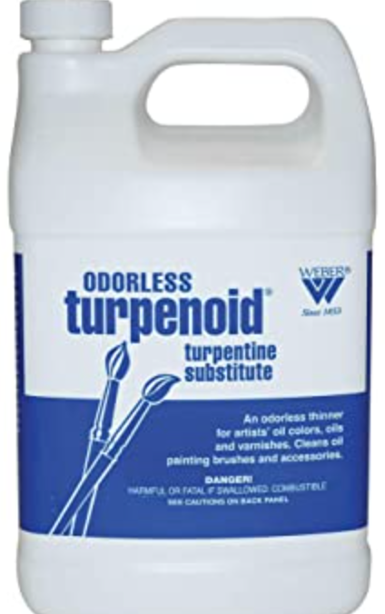

PAPER TOWELS

Glass Jar with Lid for turpenoid
CARRY-ALL TOOL CHEST/ TACKLE BOX or CARRY-ALL FOR SUPPLIES

