WATERCOLOR SUPPLY LIST
Paper: 140 lb – 300 lb paper
- Cold press Fabriano 140 lb 9 x12 sheets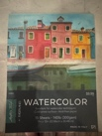 comes in book of 15 sheets
- Or large individual sheets of 300 lb Arches paper for larger projects

Paint: Hobby Lobby carries Master Touch or Winsor & Newton Paint
or Daniel Smith (if you want a professional grade)
- Cadmium Red Hue
- Cadmium Yellow Hue
- Ultramarine Blue
- Cerulean Blue Hue
- Sap Green
- Chromoxide Green
- Burnt Sienna
- Yellow Ochre
- Burnt Umber
- Paynes Grey
Brushes
Amazon carries a variety of squirrel and sable hair brushes. They are high quality and less expensive than local stores. They absorb water and paint better than synthetic brushes; however, I like synthetic brushes and will use them too. I recommend– round brushes - size 10, 6 and a small liner brush for detail. Amazon has great sets of watercolor brushes in a variety of sizes
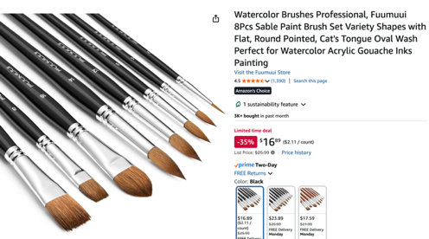
Other Supplies:
Carrier for your supplies
Pencil , kneaded eraser
Box of Kleenix
Masking tape
Any plastic palette with wells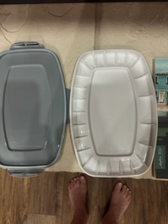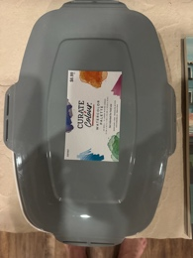
I will provide water containers and spray bottles.

